
HEALTH, SAFETY & ENVIRONMENT MANAGEMENT SYSTEM
DAN Construction Safety Manual (DCSM)
Ladders

Document Control
Document No. | 01-000001-000000-DAN-HSE-PRC-000024 | Revision | R01
Issue Date | June 2026 | Classification | Controlled — Internal
Document Owner | HSE Department | Page Format | US Letter

Table of Contents

1. Purpose
2. Scope
3. References
4. Deliverables
5. General Requirements
6. Positioning and Placement
7. Use and Types
8. Safe Ladder Working Loads
9. Inspection, Fall Protection and Storage
10. Records
11. Related Documents
Figures and Illustrations
Revision History

1. Purpose
This document provides the DAN general requirements for the correct selection, placement, use and maintenance of ladders. Except where stairways, ramps or runways are provided, ladders shall be used to give safe access to all elevations.

2. Scope
This document applies to all portable, fixed, step, extension and job-made ladders used on DAN projects.

3. References
- ANSI or European (EN) ladder standards
- DCSM — Fall Protection and Prevention — Working at Height
- DCSM — Scaffolding

4. Deliverables
- Ladder Register (Log)
- Correct ladder selection, placement and use
- Monthly inspections

5. General Requirements
- All ladders shall meet applicable ANSI or EN standards with proper labelling; self-supporting portable ladders shall be rated to at least four times the maximum intended load.
- All ladders shall be identified, registered, tagged and inspected monthly, and inspected before each use; joints shall be tight and rungs and fittings securely attached.
- Damaged or weakened ladders (split/broken rails, missing rungs, bent hinges) shall be immediately removed from site; wooden ladders shall not be painted in a way that hides defects.
- Rungs shall be parallel, level and 25–36 cm (10–14 in) on centre; metal-ladder rungs shall be slip-resistant; ladders shall be free of oil and grease.
Note: Only ONE person is allowed on a ladder at any time. Maintain three points of contact, face the ladder, do not carry heavy or bulky objects (use a tool belt or towline), and do not stand on the top two steps of a stepladder.

6. Positioning and Placement
- Straight and extension ladders shall be placed at a 4:1 slope and extend at least 1 m (3 ft) above the landing; bases shall rest on a firm, level surface (not boxes, blocks or barrels) and be secured or fitted with slip-resistant feet.
- Ladders shall be securely tied off at the uppermost support; where tying off is impractical, the base shall be secured or a person stationed at the base; flagmen or barricades shall protect ladders that could be struck by vehicles.
- Maintain a 30 in (76 cm) clear distance from rungs to the nearest object on the climbing side (24 in with deflector plates), 7 in (18 cm) behind the ladder, and 15 in (38 cm) each side from the centre line.
- Where a ladder is near a doorway, the door shall be locked shut or secured open with a person stationed to prevent use.

7. Use and Types
- Portable metal ladders shall carry a warning not to be used near electrical equipment; wooden or fibreglass ladders shall be used near electrical equipment; aluminium ladders shall not be used where contact with materials reacting with aluminium is likely.
- Ladder sections shall not be spliced together; hands shall be free while climbing (raise tools by rope); where work is performed more than 6 ft (1.83 m) above the lower surface, a properly anchored PFAS shall be used, or other methods (scaffold, lift) for long-duration or strenuous work.
- Stepladders shall have spreaders fully opened and locked, be used only when supported by all four legs, with steps facing the work; personnel shall not stand on the top platform, top step or pail shelf; stepladders shall not exceed 6 m (20 ft) and shall not be used as straight ladders.
- Extension-ladder section overlap shall be at least 1.2 m (4 ft) up to 11 m, and 1.5 m (5 ft) for 11–14.6 m; job-made (home-made) ladders are PROHIBITED.

8. Safe Ladder Working Loads
Type | Class | Duty | Working Load (kg)
IAA | Industrial | Special duty | 375
IA | Industrial | Heavy-duty industrial | 300
I | Industrial | Heavy duty | 250
II | Commercial | Medium duty | 225
III | Household | Light duty | 200
Note: Single ladders ≤ 30 ft (9.1 m); 2-section extension ladders ≤ 60 ft (18.2 m); fixed ladders ≤ 20 ft (6 m) unless fitted with a cage or fall-protection device (cages allow up to 30 ft, with offset rest platforms every 30 ft above that).

9. Inspection, Fall Protection and Storage
- Before use, personnel shall visually inspect the ladder; a defective ladder shall be tagged (green to red), reported to the Supervisor and removed from service until repaired or destroyed; an immediate inspection follows any accident, tip-over or chemical/oil exposure.
- Use 100% fall protection per the Fall Protection chapter, with appropriate platforms where ladders are used.
- The warehouse supervisor shall register all ladders and issue an inspection tag before distribution; ladders shall be stored in a well-ventilated area away from extreme heat or cold, and secured at both ends during transport.

10. Records
A register or log of all ladders in use on the project shall be maintained and made available for review on request.

11. Related Documents
- DCSM — Fall Protection and Prevention — Working at Height
- DCSM — Scaffolding
- Ladder Register / Inspection Tag

Figures and Illustrations
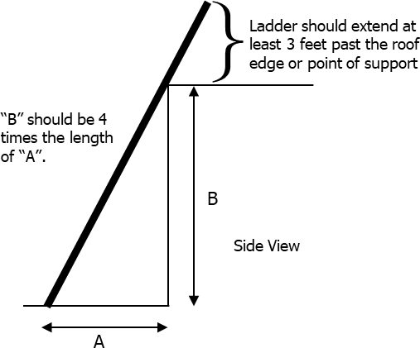
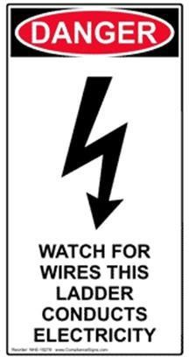
Figure 24-1
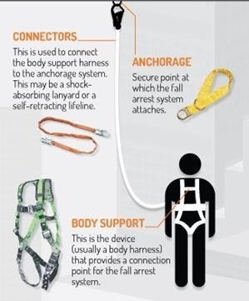
Figure 24-2 Fall Arrest System

Revision History
Rev. | Date | Description of Change | Approved By
R00 | June 2026 | Initial issue. Restructured to the DAN integrated HSSE management-system template and re-branded in accordance with the DAN Brand Book. | Project Director
R01 | June 2026 | Re-coded to the updated DAN document-numbering convention (01-000001-000000-DAN-{discipline}-{type}-{seq}). | Project Director

